***CTEC 22043***

***Object Oriented Programming***

***Lab Worksheet 03: Defining Classes***

***CT/2021/039***

**Q01 AND Q02**

**CODE:**

package Q1.Q2;  
  
public class Temperature {  
 private double celsius;  
 public Temperature(){  
 this.celsius=0;  
 }  
 public Temperature(double celsius){  
 this.celsius=celsius;  
 }  
 public double toCelsius(){  
 return celsius;  
 }  
 public void setCelsius (double celsius){  
 this.celsius=celsius;  
 }  
 public double toFahrenhiet(){  
 return(celsius * ((double) 9/5) + 32);  
 }  
 public void setFahrenhiet (double fahrenhiet){  
 this.celsius=(fahrenhiet-32) * ((double)5/9);  
 }  
}

package Q1.Q2;  
  
import java.util.Scanner;  
  
public class Main {  
 public static void main(String[] args) {  
 Scanner input = new Scanner(System.*in*);  
  
 //Q1  
  
 System.*out*.println("Enter the celsius value: ");  
 double celsius = input.nextDouble();  
  
 Q1.Q2.Temperature t1 = new Q1.Q2.Temperature();  
 t1.setCelsius(celsius);  
  
 System.*out*.println("The celsius is converted into fahrenhiet: " + t1.toFahrenhiet());  
  
 //Q2  
  
 System.*out*.println("Enter the fahrenhiet value: ");  
 double fahrenhiet=input.nextDouble();  
  
 Q1.Q2.Temperature t2 = new Q1.Q2.Temperature();  
 t2.setFahrenhiet(fahrenhiet);  
  
 System.*out*.println("The fahrenhiet is converted into celsius :" +t2.toCelsius());  
  
 }  
}

**OUTPUT Q1 and Q2**

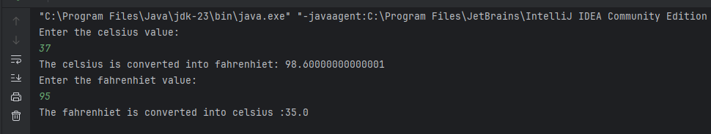

**Q03**

**Code:**

package Q3;  
  
import java.util.Scanner;  
  
public class Circle {  
 private double r;  
  
 public Circle(Scanner inputRadius) {  
 }  
 public Circle(double r){  
 this.r=r;  
 }  
  
 public double getR() {  
 return r;  
 }  
  
 public void setR(double r) {  
 this.r = r;  
 }  
  
 public double computeArea(){  
 return Math.*PI*\*r*r;  
 }  
  
 public double computeCircumference(){  
 return 2*Math.*PI*\*r;  
 }  
}

package Q3;  
  
import java.util.Scanner;  
public class Main{  
 public static void main(String[] args) {  
 Scanner scan=new Scanner(System.*in*);  
  
 System.*out*.println("Enter the radius inner circle:");  
 double innerRadius=scan.nextDouble();  
  
 System.*out*.println("Enter the radius outer circle:");  
 double outerRadius=scan.nextDouble();  
  
 Circle outerCircle=new Circle(outerRadius);  
 Circle innerCircle=new Circle(innerRadius);  
  
 double area=outerCircle.computeArea()-innerCircle.computeArea();  
 System.*out*.println("The area is"+area);  
 }  
}

**OUTPUT:**

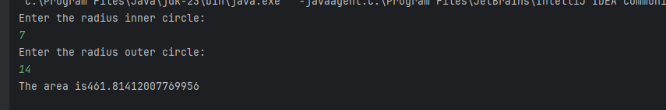

**Q04**

**CODE:**

package Q4;  
  
public class Owner {  
 private String ownerName;  
 private String phoneNo;  
  
 public Owner(String ownerName, String phoneNo) {  
 this.ownerName = ownerName;  
 this.phoneNo = phoneNo;  
 }  
  
 public String getOwnerName() {  
 return ownerName;  
 }  
  
 public String getPhoneNo() {  
 return phoneNo;  
 }  
 }

package Q4;  
  
public class Bicycle {  
  
 private Owner owner;  
  
 public Bicycle(String ownerName, String phoneNo) {  
 this.owner = new Owner(ownerName, phoneNo);  
 }  
  
 public void setOwner(Owner owner) {  
 this.owner = owner;  
 }  
  
 public Owner getOwner() {  
 return owner;  
 }  
  
 }

package Q4;  
  
public class BicycleTest {  
  
 public static void main(String[] args) {  
 Bicycle myBike = new Bicycle("Sashini", "0710648891");  
 System.*out*.println("owner:" + myBike.getOwner().getOwnerName());  
 System.*out*.println("Phone No: " + myBike.getOwner().getPhoneNo());  
 }  
 }

**OUTPUT:**

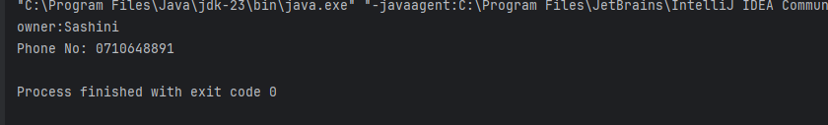

**Q05**

**CODE:**

package Q5;  
  
public class Course {  
 private String courseName;  
 private String courseCode;  
 private Lecturer lecturer;  
  
 public Course(String courseName,String courseCode,Lecturer lecturer ){  
 this.courseName = courseName;  
 this.courseCode = courseCode;  
 this.lecturer = lecturer;  
 }  
  
 public String getCourseName(){  
 return courseName;  
 }  
  
 public void setCourseName(String courseName){  
 this.courseName = courseName;  
 }  
  
 public String getCourseCode(){  
 return courseCode;  
 }  
  
 public void setCourseCode(String courseCode) {  
 this.courseCode = courseCode;  
 }  
  
 public Lecturer getLecturer(){  
 return lecturer;  
 }  
  
 public void setLecturer(Lecturer lecturer) {  
 this.lecturer = lecturer;  
 }  
}

package Q5;  
  
public class Lecturer {  
 private String lecturerName;  
 private String courseTeaching;  
  
 public Lecturer(String lecturerName,String courseTeaching){  
 this.lecturerName = lecturerName;  
 this.courseTeaching = courseTeaching;  
 }  
  
  
 public String getLecturerName() {  
 return lecturerName;  
 }  
  
 public void setLecturerName(String lecturerName) {  
 this.lecturerName = lecturerName;  
 }  
  
 public String getCourseTeaching() {  
 return courseTeaching;  
 }  
  
 public void setCourseTeaching(String courseTeaching) {  
 this.courseTeaching = courseTeaching;  
 }  
}

package Q5;  
  
public class Student {  
 private String studentName;  
 private String degreeName;  
 private String courseFollowing;  
  
 public Student(String studentName,String degreeName,String courseFollowing){  
 this.studentName = studentName;  
 this.degreeName = degreeName;  
 this.courseFollowing = courseFollowing;  
 }  
  
 public String getStudentName() {  
 return studentName;  
 }  
  
 public void setStudentName(String studentName) {  
 this.studentName = studentName;  
 }  
  
 public String getDegreeName() {  
 return degreeName;  
 }  
  
 public void setDegreeName(String degreeName) {  
 this.degreeName = degreeName;  
 }  
  
 public String getCourseFollowing() {  
 return courseFollowing;  
 }  
  
 public void setCourseFollowing(String courseFollowing) {  
 this.courseFollowing = courseFollowing;  
 }  
}

package Q5;  
  
public class Main {  
 public static void main(String[] args) {  
 Lecturer lecturer = new Lecturer("Dr.Razeen", "Data Structure");  
  
 Course course = new Course("Data Structure", "CTEC 12063",lecturer);  
  
 Student student = new Student("Sasikala B.R.S", "BICT", course.getCourseName());  
  
 System.*out*.println("Course Details:");  
 System.*out*.println("Course Name: " + course.getCourseName());  
 System.*out*.println("Course Code: " + course.getCourseCode());  
 System.*out*.printf("Lecturer: %s%n", course.getLecturer().getLecturerName());  
  
 System.*out*.println("\n");  
  
 System.*out*.println("Student Details:");  
 System.*out*.println("Student Name: " + student.getStudentName());  
 System.*out*.println("Degree: " + student.getDegreeName());  
 System.*out*.println("Following Course: " + student.getCourseFollowing());  
 }  
}

**OUTPUT:**

